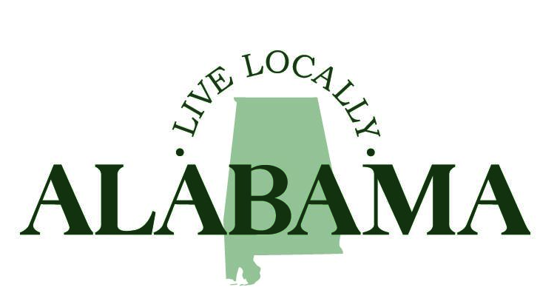

Background

The Alabama League of Municipalities (ALM) launched Live Locally Alabama, a quality-of-life campaign, in September 2024 with the goal of encouraging civic engagement, instilling community pride and highlighting the crucial role municipal government plays in the daily lives of Alabama’s citizens. The items below provide ideas for local officials to incorporate into their every day talking points to accomplish the campaign’s goals as they highlight their city or town’s unique assets and services. Access all videos, graphics, press releases, flyers, logos, the logo style guide and more at: https://almonline.org/LiveLocallyAlabama.aspx. If you have any questions, please reach out to ALM’s Communications Director Lori Jhons at ljhons@almonline.org.

Goals:
- Create a vision for living locally in Alabama.
- Increase public awareness about local government.
- Encourage civic engagement and community investment.
- Educate lawmakers about services provided to ensure sustainable revenue streams and a continuation of local municipal authority.

Top Line Messaging for Municipal Leaders:
The League recently collected data from a voluntary survey of municipalities that focuses on the costs related to public safety; water, sewer and road infrastructure; and parks and recreation, which all typically account for the majority of a municipality’s expenses outside of payroll. We must take the time to share how much it costs to build roads, develop parks and provide quality of life services for building strong communities where people want to live, work, play, shop, invest and raise families. Having your help sharing this data can be a game changer.
Data points:
- On average, it costs more than $143,000 to support one police officer’s salary and equipment.
- The average cost for one police cruiser is over $63,000.
- On average, it costs more than $59,000 to employ one firefighter.
  - FYI, a firefighter’s equipment is more communal versus how a police officer usually has his own individual gear.
- The average cost for one fire truck is over $1.6 million.
- On average, it costs between $1.25 million to $4 million for one mile of road construction.
- It generally costs about $340 to fill one pot hole.
- It costs approximately $48 million to construct and maintain water and sewer infrastructure. (piping/sanitation/personnel)
- It costs approximately $450,000 to construct one acre for an active park.
- It costs approximately $750,000 to build a ball field.
- It costs approximately $400,000 to build a splash pad.
- It costs approximately $3 million to $6 million to construct a pickleball complex.

- Live Locally, Play Locally, Explore Locally
  - Alabama has an abundance of natural resources, from white sandy, Gulf Coast beaches to the Appalachian foothills. The state boasts multiple activities including boating, fishing (salt and freshwater), hunting, local cultural and arts events and festivals.
  - Local municipalities provide sports and recreation complexes for families to enjoy.
- Shop Locally, Eat Locally
  - Shopping and eating locally creates sustainable economic growth and attracts economic investment for communities. When you shop and eat locally, your money stays local. It impacts employee wages, new job creation and overall growth in our local communities. You can find local businesses by checking your chamber of commerce directory or by taking a stroll through downtown or main street. Supporting local businesses means keeping more money in our local communities, which helps everyone prosper.
- Work Locally
  - Alabama is home to a wide variety of industries. Workforce development plays a critical role in preparing our citizens for work. The state also continues to focus on high-paying manufacturing jobs, automotive jobs, aerospace and defense opportunities and maritime careers. See resources below:
    - Workforce Alabama
    - Alabama Department of Labor
    - Made in Alabama
    - Innovate Alabama
- Learn Locally
  - Alabama sets high public education standards and has one of the highest graduation requirements in the country.
  - Alabama is home to 30 four-year colleges and universities and 26 two-year community, technical, and junior colleges. Of them, 14 are Historically Black Colleges and Universities, giving Alabama the most HBCUs in the nation. The schools are strategically located throughout the state to give citizens better access to in-state education opportunities.
  - Alabama’s First Class Pre-K program leads the nation in quality education.

How Local Government Supports Communities
- Public Safety
  - Through law enforcement, response and public education, local governments protect our citizens, prevent crime and manage disasters effectively. Local governments also partner with state agencies and associations, community leaders and local organizations to provide emergency assistance after natural disasters and other emergencies.
- Services and Infrastructure
  - Every city and town has unique needs in their communities and local governments take the lead in providing services to enhance the lives of citizens.
- Sustainable Growth and Development
  - Local governments promote intentional growth designed to equally serve the economy, community and the environment.
- Agriculture
  - Many local governments facilitate partnerships with farmers and agencies to provide communities with fresh local produce through farmer’s markets and initiatives providing quality foods while promoting a strong local economy.

Suggested Talking Point Ideas for Public Involvement
- Local governments are the backbone of society and have a profound impact on the day-to-day life of Alabama citizens. City and town councils, school boards, judges and other county officials make decisions that have the biggest influence on daily life. Getting involved in local government promotes a collaboration between citizens and government in coming up with new ways of relating and working together.
- Community engagement is pivotal to encourage more equitable, sustainable decisions to continue to improve livability in our local communities. Citizens can get involved by attending council meetings and community events; engaging in elections; building relationships with local and state leaders; volunteering; and participating in community initiatives and improvement projects.
- Connect with local officials on social media and follow your municipality’s social media page.

Communications Strategy
- Incorporate these talking points into your every day conversations with legislators and the public at events, council meetings, civic clubs, student leadership groups, schools, etc.
- Social media
  - Promote the Live Locally Alabama campaign on social media (generic content is on our website including a sample social media calendar with lots of ideas).
  - Engage with citizens by posting new initiatives and services on social media.
    - Infrastructure projects/completion of big milestones
    - Community/housing initiatives
    - Economic development announcements/job announcements
    - Arts and cultural events
- Send a press release in support of Live Locally Alabama to local media outlets (press release on website).
- Post the campaign videos, graphics, and articles on your municipal websites

